Smart Dustbin
Abstract:
At the same phase there is an increase in waste production. Waste management has been a crucial issue to be considered. This proposal is a way to achieve this good cause. In this project smart dustbin is built on a microcontroller based platform Arduino Uno board which is interfaced with the Servo motor and ultrasonic sensor. Ultrasonic sensor is placed at the top of the dustbin which will measure the stature of the dustbin.
Requirments:
12v Adaptor:
Arduino Uno
Arduino Nano
HC-SR04 Ultrasonic Sensor:
Micro Servo Motors
Cardboard

Ultrasonic Sensor:

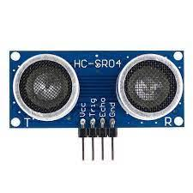
Ultrasonic sensors work by sending out a sound wave at a frequency above the range of human hearing. The transducer of the sensor acts as a microphone to receive and send the ultrasonic sound. Our ultrasonic sensors, like many others, use a single transducer to send a pulse and to receive the echo. The sensor determines the distance to a target by measuring time lapses between the sending and receiving of the ultrasonic pulse. Figure 2 shows the pin configuration for ultrasonic sensor module (HC-SRO4) which includes.

- Vcc (5 volt Supply )
- Trigger pin
- Echo pin
- Gnd (0volt)
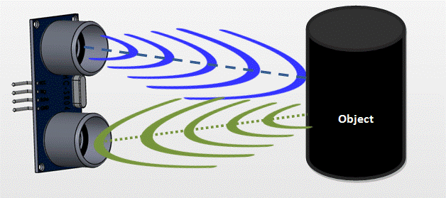

Servo Motor:

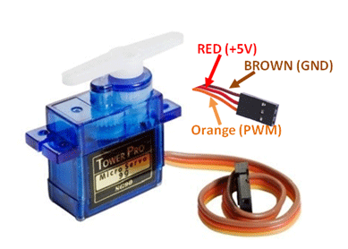

A servo motor is an electrical device which can push or rotate an object with great precision. If you want to rotate an object at some specific angles or distance, then you use servo motor. It is just made up of simple motor which run through servo mechanism. If motor is used is DC powered then it is called DC servo motor, and if it is AC powered motor then it is called AC servo motor. We can get a very high torque servo motor in a small and light weight packages.

Arduino UNO:

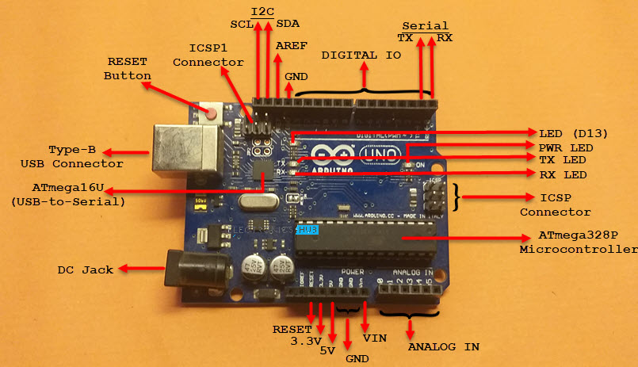

Arduino is an open-source platform used for building electronics projects. Arduino consists of both a physical programmable circuit board (often referred to as a microcontroller) and a piece of software, or IDE (Integrated Development Environment) that runs on your computer, used to write and upload computer code to the physical board.

Circuit Diagram:

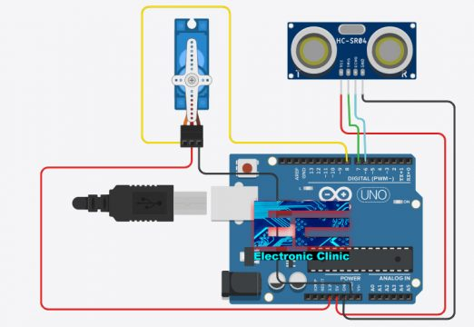

Program:

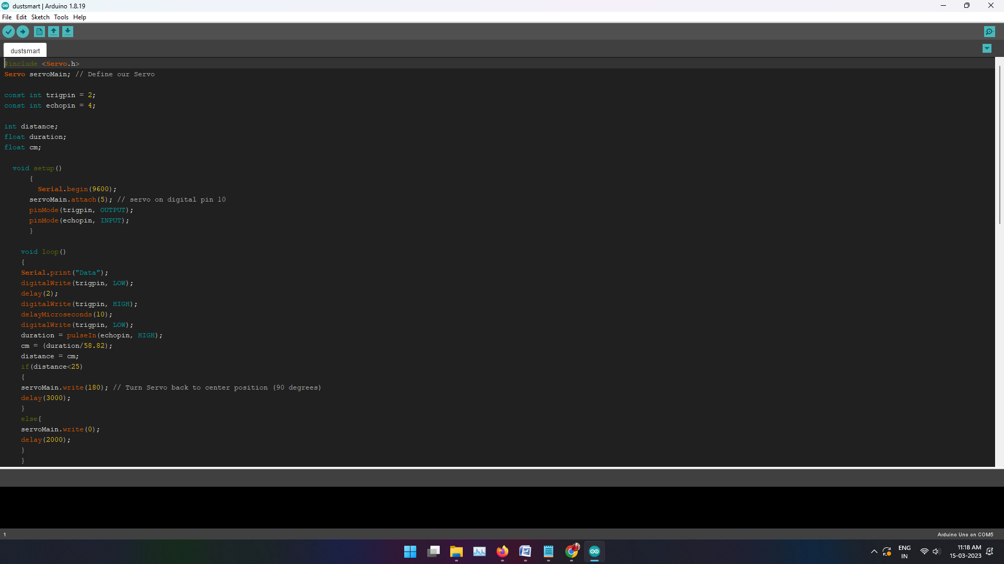

Output:



